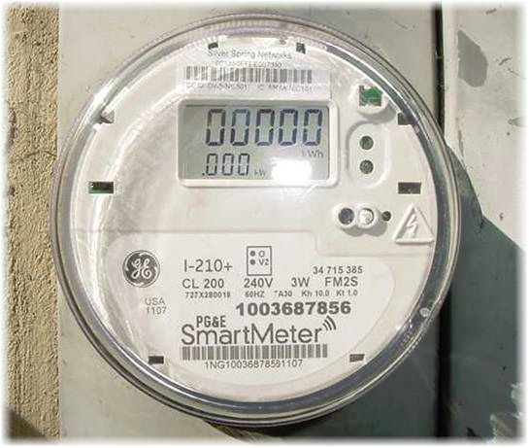
Helping our home’s electricity …
Refrigerators, Smart Meters, Air Purifiers & More …

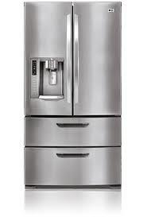
Electricity has changed a lot in the last 30 years. Our homes were designed with wires to carry electricity from one outlet to another via a network from an analog home meter. Some power companies are replacing the original meters with a wireless device, known as a Smart Meter. This comes with more surges & spikes, which are hard on appliances & electronics, and our human bodies. These constant low-grade frequencies stress our homes electrical flow & can cause chronic stress & dehydration in our bodies.

Dr. David Carpenter - https://www.youtube.com/watch?v=n7L21XOC2wA
Dr. Dietrich Klinghardt - https://www.youtube.com/watch?v=HDHd11WvLa4&ab_channel=CarloMer Engineer speaks out - https://www.emfanalysis.com/tedx-wireless-wake-up-call/

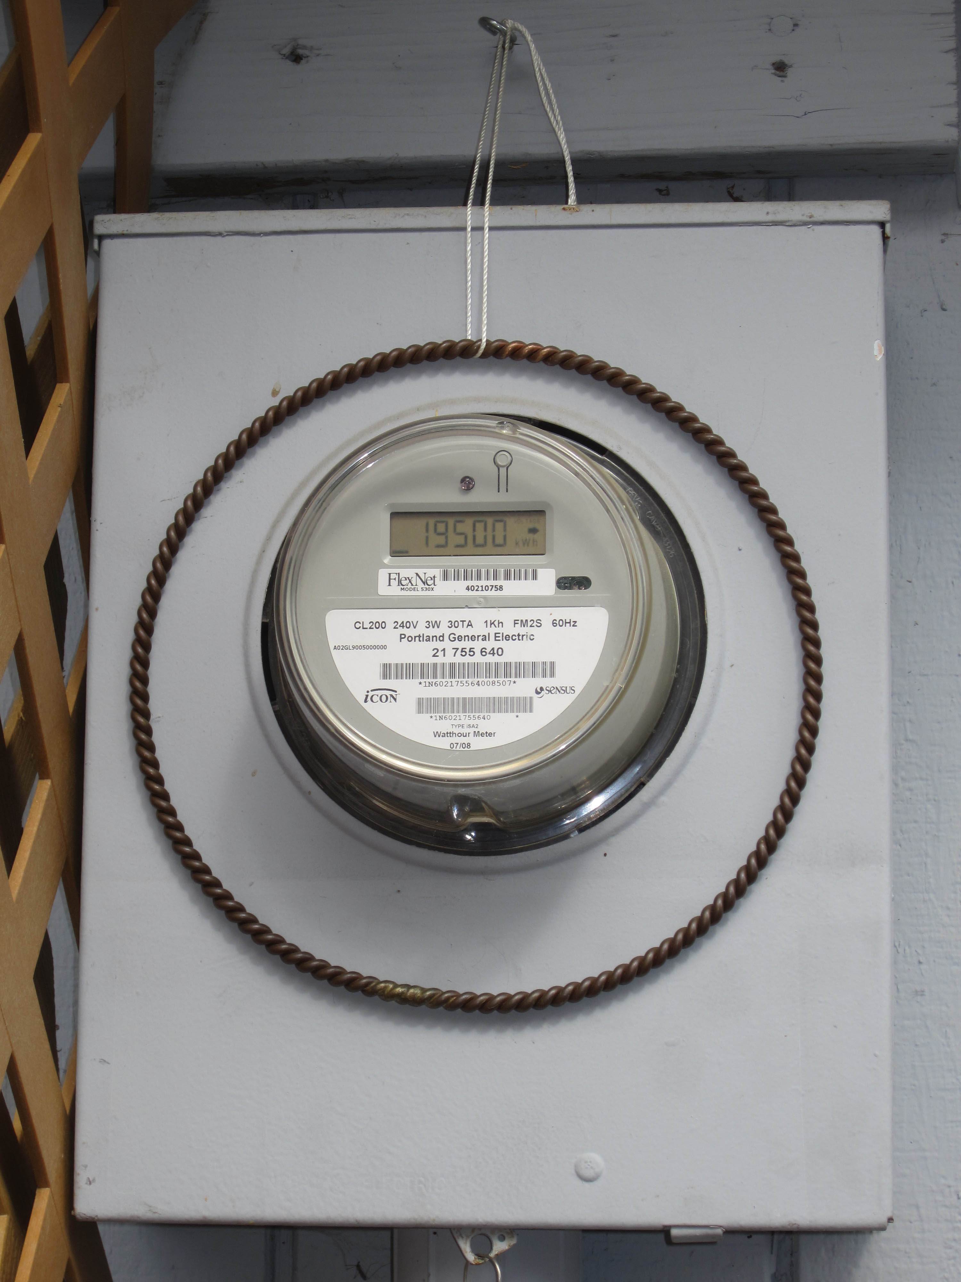
A Light Life Technology copper ring placed around a smart meter can help smooth out the sporadic flow of electricity into buildings too. This would also protect appliances, electronic devices, people & pets.

We recommend having a single surge protector on each susceptible device (with a motor) … refrigerators, washing machines, electronic ionizers, garage door opener and more. The traditional strip surge protectors let too much power through. To further protect your home from dirty electricity and the risk of fires from wifi Smart Meters, see our info on “grounding & balancing energy flow”.

For more hints about whole home & personal harmonizing and preventative things that help smooth energy flow, use and ease ideas, please check out: www.airWaterAndwellness.com
Air, Water & Wellness @ 503-524-4862

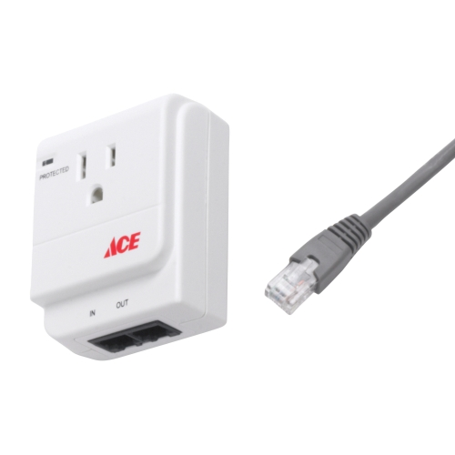
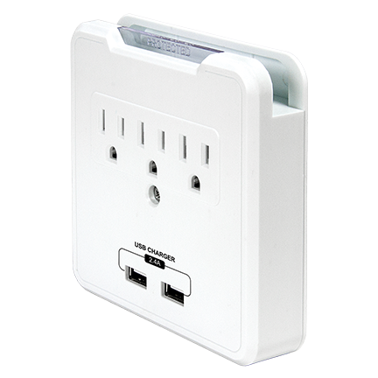
~ Single Surge Protectors ~

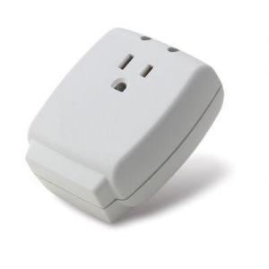
… rated around 1000 Joules for Refrigerators, Washing Machines & more (including the Flair & Fresh Air Purifiers), 700-800 joules for the EcoBox air machine)

Your local hardware or home improvement store may carry these. You can also get these here at Air, Water & Wellness.

Air, Water & Wellness *** www.airWaterAndwellness.com *** 503-524-4862

